Requirements for VRNT Application

# Introduction

There is need felt to develop an application to manage the different activities of VRNT. This document attempts to describe these needs in the form of formal requirements

# Objective

Following are the high-level objectives of the applications

* Effectively /efficiently conduct the varshikam & poorthy exams
  + Currently physical forms are used for applications; make it online
  + Currently Excel forms are used to manage the application processing, evaluation, etc. These activities need to be streamlined; Reduce the dependency on manual operations
  + Evaluations forms are manually entered and later processed manually as well. These need to be automated as much as possible
* Have a quantitative way of assessing the
  + Quality of students
  + Quality of Exams
  + Quality of paatashala
  + Effectiveness of VRNT assistance to Paatashala
  + Effectiveness of HNY assistance

# Use Cases

## Access Control

### User Access creation

* User “Admin” will be created by default.
  + This user will have all permissions.
* Each user will be assigned unique id
  + 1. How to generate & assign this unique id?
* Access to the system will be password controlled
* New users
  + Anyone wants to access the system has to put in a request for access;
  + New user will be created by the admin and password will be sent to user;
  + ~~Admin should validate whether the user is legitimate~~
    1. ~~How to do this user validation?~~
  + The new user will be forced to set (or change) the password on the initial access to the system
* Will start with following levels of users
  + Admin
  + VRNT Trustees
  + VRNT Office staff
  + VRNT Volunteer
  + Patashala manager
  + Individual users
    - Vidyaarthy
    - Adhyapakar
    - Pareekshadhikari - Examiner
* Fine grain access control is needed
* User once created will never be deleted;
  + The information about the user is a valuable history record for the Trust;
  + User can be marked (inactive, etc.)
  + User access can be barred

### User profile creation

* Patashala Manager can create new users; This is for Vidyarthi-s of that paatashala
* Once access is granted; user should be able to populate their own profile information
  + 1. What are the fields those cannot be edited?
    2. What are the fields those can be edited, but only on access-privilege?
* User could be one or more of the following
  + Student – Vidyarthi
  + Father
  + Guru
  + Examiner – Pareekshadhikari
* Specific information needed for the profile are given in Sec 4.1 User Data

### Entering Paatashala information

* Patashala profile information can be created by
  + 1. Need update
  + VRNT Volunteer
  + VRNT office staff
  + VRNT Trustee
  + VRNT admin
* Specific information needed for the profile are given in 4.2 Patashala Profile

## Varshikam – Annual Exam

Typical steps for a varshikam

* Patashala will send a request for varshikam
* The request will contain the list of students (Vidyaarthi-s), and the portion to be tested for each student
* The students may belong to various veda / shaka -s
* VRNT will assign one or more examiners (pareekshadikaris) for the varshikam
* Examiner will visit the paatashala, conduct the exams & send the results to VRNT

### Entering Vaarshikam Application

* A specific interface will be created to register for Varshikam exam
* Patashala admin can register the application
* Deciding exam dates and Assignment of Pareekshadikari
* **Pareekshadikari will conduct the exams and provide the results**
* **VRNT admin will enter the results**

### Entering results of the Varshikam Exam

* A specific interface (similar Google form) will be created to enter the Varshikam exam results
* Patashala admin can register the application
  + 1. Who will be right person for this?
* ~~The data from the application will be cross checked & uploaded to VRNT application data base by an offline script~~

### Validation needed for Varshikam Exam

* Is there an overlap of the portion between this year & Previous years
* How much has the student studied this year?
  + Should there be a lower limit for the portion to be tested? Anything less than that lower limit will not be tested. That student is not eligible for varshikam
  + Krishna Yajur vedam – 900 panchathi (this is only for first year)
    1. Need limit for every year
    2. Need data for other vedams

No upper limit needed for No. of varshikam

## Poorthy Exam

Typical process for Poorthy exam

* After the student has completed all the portions, he is eligible to apply for poorthy exam
* VRNT conduct Poorthy exams twice a year – one for Shakara Jayanthi and another for Vijayadasami
* VRNT will open the window for Poorthy exam
* Students can send application for the exam
* On the day of the exam, once the student is examined, examiner will provide the marks & Results
* VRNT admin will enter the results
* Certificates are printed for eligible candidates
* Certificates are awarded to the vidyaartheees by Swamji, on (Shankara Jayanthi day OR Vijay dasami Day), along with cash award.

### Opening up of Poorthy exam

* VRNT admin decides the date for the poorthy exam
* Creates a new poorthy exam in the system
* Send notification to all eligible Vidyarthees AND all Patashalas as well

### Entering poorthy application

* Vidyarthy can login to the system and apply for the poorthy exam
* If the application is received from a vidyarthy for poorthy exam, System should automatically show whether the user (Vidyarthi) is eligible for poorthy exam, based on previous varshikam exam detail.
  + Need to complete all portions in Varshikam, before applying for Poorthy
  + Atleast 3 (three) varshikams should have been completed
  + Requisite Level Sanskrit exam should also be completed

### Conducting poorthy exam

#### Assigning Pareekshadikari information

* + 1. How to automate this process? This may be left manual for now. What kind of support we need from the system for this activity?

#### Automate creation/printing of hall ticket

* The hall ticket should be automatically generated in a printable format

### Statistics for Poorthy exam – Report generation

* General Pass percentage of students
  + Veda / shaka wise
* State wise statistics
* No. of years/months elapsed (From paatashala entry date) before appearing for poorthy exam

### Printing

#### Printing hall tickets

* The hall tickets for the poorthy exam students should printed
  + 1. The hall ticket format is needed

#### Printing Attendance sheet

* It should be possible to print the attendance sheets as required for conducting the poorthy exams

## Reports Needed about Patashalas – Report Generation

* No of students appearing for VRNT exams
  + Year wise
  + Qualification wise (moolam, kramam, Ghanam, etc.)
  + Quality of students
    - Pass percentage
    - Level wise (first class, second class, etc.)
* For Patahshlas getting Assitance some more check
  + Are they coming for Varshikam & Poorthy
  + How many are missing poorthy exam (leaving without completing)
* For a given paatashala, are all the students from previous year are appearing this year for Varshikam (Or poorthy) exam. If not, reason for the same
  + Has the student has left the paatashala, without appearing for poorthy exam?

## HNY Vidyarthi-s

### Entering HNY Application

This is probably, same as creating a new user. Mark as HNY. A periodic report should be generated for HNY students, covering following aspects.

### Report Generation

* Is the student appearing for Varshikam?
* Time taken to appear for Poorthy exams
* Should there be an upper limit for appearing for poorthy exam?
  + If the upper limit is exceeded, can the monthy stipend be suspended/Stopped?
* Quality of the student
* General queries (OR assessment)
  + What is the general quality of HNY students?
  + Duration of Studies for each level of graduation

## Populating earlier year data

### Data from Excel files

### Data from forms

### Data from other sources

# Data Structures

## User Data

* + Unique id
  + Adhaar number
  + Mobile number
  + E-mail address
  + Date of birth
  + Photo
  + Address
  + Type of user
    - Vidyarthi
    - Guru / Adhyapakar
    - Father
    - Pareekshadhikari
* A person can be Student, Father, Guru, Pareekshadikari, as well as Adhyapakar. Application should flexible enough to allow more than one role to a person, all at the same time
  + Is the user HNY?
  + Veda / Shaka (Studying)
  + Gothram / Soothram
  + Swashaka
  + Paatashala (more than one)
    - Date of joining the patashala
  + Varshikam data for all years
    - For each varshikam
      * Panchaathi included for this vaarshikam – for each student
        + No. of Panchathi (Specific to each veda / shaka)
        + Specific Panchathi (Specific to each veda / shaka) numbers included for test
    - Should there be an upper limit for Varshikam
  + Poorthy exam details
    - Could be more than one
    - One for each level of exam
    - If there is a repeat exam, that should be recorded too
  + Guru & Pareekshadhikari should certify that the student is engaged full time;
    - Not studying outside the paatashala – in regular schools
  + Swashaka certification from Guru & Paraeekshadikari needed (First varshikam)
  + HNY related data
    - Registration Date
    - Father / Guru
  + Qualification
  + If VRNT qualified, details of the same
  + Sanskrit Exam qualification
    1. At the time of initial provisioning of the user, admin will add few details; Need to explicitly mention those fields
    2. Some of these fields can be entered by the user; Need to explicitly mention those fields
    3. What the fields that the user can update later?
  + Bank Details
    - Bank Name
    - Branch
    - Account number
    - IFSC code

## Patashala Profile

* Name
* Address
* Phone number
* E-mail address
* Management info
  + Name of the trust
  + List of Trustees
    - Name
    - Mobile number
* Is VRNT providing financial assistance? (Yes / No)
* No. of students for each Veda / shaka (optional)
* List of Students
  + vedam / Shaka wise
  + Joining date
  + Leaving date
* List of Adhyapakar
  + vedam / Shaka wise
  + Joining Date
  + Leaving Date
* Bank details of the Trust
  + Bank Name
  + Branch
  + Account number
  + IFSC code

## Varshikam Application

* Varshikam Application Id
  + System needs to automatically generate this Id
  + This Id is needed to link the varshikam details to the User profile And vice Versa
* Name of the paatashala
* Adhyapakar
* Pareekshadikari
* List of students for the specific varshikam
  + Veda / Shaka wise
  + Portion covered for each student
  + Result of the exam

## Poorthy Exam Application

* Poorthy Exam Application Id
  + System needs to automatically generate this Id
  + This Id is needed to link the Poorthy exam details to the User profile And vice Versa
* Dates of examination
* List of students
  + Is it a repeat exam?
  + Information about previous exams (Need to be tailored for each veda / shaka)
    - Varshikam (At least 3 needed)
    - Moolam
    - Kramam
    - Ganam
    - Lakshanam
  + For each level pre-requisite needed to be checked
* List of Pareekshadhikari-s
  + Student assignment information for each Pareekshadhikari
* Results of the exam

# Data Structures with validation criteria

## User Data

|  |  |  |  |  |
| --- | --- | --- | --- | --- |
| **Name of the field** | **Type** | **Validation Criteria** |  | **When & Who can update?** |
| Unique Id |  |  |  |  |
| Adhaar Number |  |  |  |  |
| Mobile number |  |  |  |  |
| E-mail Address |  |  |  |  |
| Date of Birth |  |  |  |  |
| Photo |  | Only *.jpg is allowed Size limit ??? |  |  |
| Address |  | Need State & PIN code |  |  |
| Type of user |  | * Vidyarthi * Guru / Adhyapakar * Father * Pareekshadhikari * Admin * Trustee * Office staff * Volunteer * Patashaala Manager | Features available for each of this type may be different |  |
| Is the user HNY Vidyaarthi? |  | YES or NO |  |  |
| HNY details | * Registration Date * HNY Number * Father / Guru details |  |  |  |
| Veda & Shaka |  | Rig - Shakala  Krishna Yajur - Thaitriyam  Shukla Yajur - Kanva  Shukla Yajur - Madhyanthina  Sama - Kouthuma  Sama - Jaimini  Sama - Ranayani  Atharva - Saunaka  Atharva - Pippalad |  |  |
| Gothram | Text |  |  |  |
| Soothram | Text |  |  |  |
| Swashaka | Yes OR No | Also Need  Id of the Person who verified this | Typically, this is verified by the Pareekshadhikari who is in charge of first varshikam |  |
| Patashala | Link to patashala |  | The paatashala where the student is studying; If Student has studied in more than one paatashala, all of them can be included here |  |
| Patashala Joining date |  |  |  |  |
| Varshikam details |  |  | There can be more than one varshikam. The portion covered in each varshikam should be included |  |
| Poorthy Exam details |  |  | Could be more than one  One for each level of exam  If there is a repeat exam (withdrawn, Absent, fail, etc.) that should be recorded too |  |
| Qualification |  |  | Has the candidate appeared for exams in other organizations? Those details |  |
| Sanskrit exam qualification |  |  | Discretionary option needed |  |
| Bank Details | Bank Name  Branch  Account Number  IFSC code  Bank Pass Book first page scan copy, having all the above details |  |  |  |

## Varshikam Data

### Rig Vedam

|  |  |  |  |  |  |  |
| --- | --- | --- | --- | --- | --- | --- |
| Book (Ashtakam) | Chapter (Prashnam) | VARGA | Link to varshikam | Date of varshikam | Marks obtained | Pass status |
| 1 | 1 | 37 |  |  |  |  |
| 2 | 38 |  |  |  |  |
| 3 | 35 |  |  |  |  |
| 4 | 29 |  |  |  |  |
| 5 | 31 |  |  |  |  |
| 6 | 32 |  |  |  |  |
| 7 | 37 |  |  |  |  |
| 8 | 26 |  |  |  |  |
| 2 | 1 | 26 |  |  |  |  |
| 2 | 27 |  |  |  |  |
| 3 | 26 |  |  |  |  |
| 4 | 29 |  |  |  |  |
| 5 | 29 |  |  |  |  |
| 6 | 32 |  |  |  |  |
| 7 | 25 |  |  |  |  |
| 8 | 27 |  |  |  |  |
| 3 | 1 | 34 |  |  |  |  |
| 2 | 26 |  |  |  |  |
| 3 | 31 |  |  |  |  |
| 4 | 25 |  |  |  |  |
| 5 | 26 |  |  |  |  |
| 6 | 30 |  |  |  |  |
| 7 | 27 |  |  |  |  |
| 8 | 26 |  |  |  |  |
| 4 | 1 | 33 |  |  |  |  |
| 2 | 28 |  |  |  |  |
| 3 | 31 |  |  |  |  |
| 4 | 36 |  |  |  |  |
| 5 | 30 |  |  |  |  |
| 6 | 25 |  |  |  |  |
| 7 | 35 |  |  |  |  |
| 8 | 32 |  |  |  |  |
| 5 | 1 | 27 |  |  |  |  |
| 2 | 30 |  |  |  |  |
| 3 | 30 |  |  |  |  |
| 4 | 30 |  |  |  |  |
| 5 | 27 |  |  |  |  |
| 6 | 25 |  |  |  |  |
| 7 | 33 |  |  |  |  |
| 8 | 36 |  |  |  |  |
| 6 | 1 | 40 |  |  |  |  |
| 2 | 40 |  |  |  |  |
| 3 | 49 |  |  |  |  |
| 4 | 54 |  |  |  |  |
| 5 | 38 |  |  |  |  |
| 6 | 38 |  |  |  |  |
| 7 | 39 |  |  |  |  |
| 8 | 33 |  |  |  |  |
| 7 | 1 | 41 |  |  |  |  |
| 2 | 33 |  |  |  |  |
| 3 | 26 |  |  |  |  |
| 4 | 28 |  |  |  |  |
| 5 | 33 |  |  |  |  |
| 6 | 28 |  |  |  |  |
| 7 | 30 |  |  |  |  |
| 8 | 29 |  |  |  |  |
| 8 | 1 | 30 |  |  |  |  |
| 2 | 24 |  |  |  |  |
| 3 | 28 |  |  |  |  |
| 4 | 31 |  |  |  |  |
| 5 | 27 |  |  |  |  |
| 6 | 27 |  |  |  |  |
| 7 | 30 |  |  |  |  |
| 8 | 49 |  |  |  |  |

### Krishna Yajur Vedam

* + 1. Is varshikam done only for Moolam OR kramam as well?

Typically, varshikam is only for Moolam; We need confirmation that Padam/Kramam is completed by pareekshadikari

|  |  |  |  |  |  |  |
| --- | --- | --- | --- | --- | --- | --- |
| Book  (Kaandam) | Chapter  (Prashnam) | No of verses (panchathi) | Link to varshikam | Date of varshikam | Pass status |  |
| Kaandam – 1 | 1 | 28 |  |  |  |  |
| 2 | 34 |  |  |  |  |
| 3 | 31 |  |  |  |  |
| 4 | 54 |  |  |  |  |
| 5 | 51 |  |  |  |  |
| 6 | 51 |  |  |  |  |
| 7 | 51 |  |  |  |  |
| 8 | 42 |  |  |  |  |
| Kaandam – 2 | 1 | 65 |  |  |  |  |
| 2 | 71 |  |  |  |  |
| 3 | 56 |  |  |  |  |
| 4 | 48 |  |  |  |  |
| 5 | 74 |  |  |  |  |
| 6 | 70 |  |  |  |  |
| Kaandam - 3 | 1 | 42 |  |  |  |  |
| 2 | 46 |  |  |  |  |
| 3 | 36 |  |  |  |  |
| 4 | 46 |  |  |  |  |
| 5 | 36 |  |  |  |  |
| Kaandam - 4 | 1 | 46 |  |  |  |  |
| 2 | 48 |  |  |  |  |
| 3 | 36 |  |  |  |  |
| 4 | 37 |  |  |  |  |
| 5 | 27 |  |  |  |  |
| 6 | 46 |  |  |  |  |
| 7 | 39 |  |  |  |  |
| Kaandam - 5 | 1 | 59 |  |  |  |  |
| 2 | 64 |  |  |  |  |
| 3 | 48 |  |  |  |  |
| 4 | 58 |  |  |  |  |
| 5 | 62 |  |  |  |  |
| 6 | 54 |  |  |  |  |
| 7 | 58 |  |  |  |  |
| Kaandam – 6 | 1 | 76 |  |  |  |  |
| 2 | 59 |  |  |  |  |
| 3 | 62 |  |  |  |  |
| 4 | 51 |  |  |  |  |
| 5 | 42 |  |  |  |  |
| 6 | 43 |  |  |  |  |
| Kaandam – 7 | 1 | 52 |  |  |  |  |
| 2 | 50 |  |  |  |  |
| 3 | 42 |  |  |  |  |
| 4 | 53 |  |  |  |  |
| 5 | 54 |  |  |  |  |
| Ashtakam -1 | 1 | 80 |  |  |  |  |
| 2 | 50 |  |  |  |  |
| 3 | 65 |  |  |  |  |
| 4 | 66 |  |  |  |  |
| 5 | 59 |  |  |  |  |
| 6 | 76 |  |  |  |  |
| 7 | 64 |  |  |  |  |
| 8 | 37 |  |  |  |  |
| Ashtakam – 2 | 1 | 60 |  |  |  |  |
| 2 | 73 |  |  |  |  |
| 3 | 50 |  |  |  |  |
| 4 | 80 |  |  |  |  |
| 5 | 45 |  |  |  |  |
| 6 | 94 |  |  |  |  |
| 7 | 66 |  |  |  |  |
| 8 | 79 |  |  |  |  |
| Ashtakam -3 | 1 | 63 |  |  |  |  |
| 2 | 85 |  |  |  |  |
| 3 | 79 |  |  |  |  |
| 4 | 19 |  |  |  |  |
| 5 | 30 |  |  |  |  |
| 6 | 37 |  |  |  |  |
| 7 | 130 |  |  |  |  |
| 8 | 91 |  |  |  |  |
| 9 | 86 |  |  |  |  |
| Katakam | 1 | 49 |  |  |  |  |
| 2 | 62 |  |  |  |  |
| 3 | 56 |  |  |  |  |
| Arunam | 1 | 132 |  |  |  |  |
| 2 | 24 |  |  |  |  |
| 3 | 53 |  |  |  |  |
| 4 | 94 |  |  |  |  |
| 5 | 108 |  |  |  |  |
| 6 | 27 |  |  |  |  |
| 7 | 23 |  |  |  |  |
| 8 | 9 |  |  |  |  |
| 9 | 10 |  |  |  |  |
| 10 | 101 |  |  |  |  |
| Mantra Prashnam | 1 |  |  |  |  |  |
| 2 |  |  |  |  |  |

### Shukla Yajur – Kanva

|  |  |  |  |  |  |
| --- | --- | --- | --- | --- | --- |
| **Book (Dasakam)** | **Chapter - Adhyayam** | **No. of verses (Manthram)** | Link to varshikam | Date of varshikam | Pass Status |
| Dasakam - 1 | 1 | 50 |  |  |  |
| 2 | 60 |  |  |  |
| 3 | 76 |  |  |  |
| 4 | 49 |  |  |  |
| 5 | 55 |  |  |  |
| 6 | 50 |  |  |  |
| 7 | 40 |  |  |  |
| 8 | 32 |  |  |  |
| 9 | 46 |  |  |  |
| 10 | 43 |  |  |  |
| Dasakam - 2 | 1 | 47 |  |  |  |
| 2 | 85 |  |  |  |
| 3 | 116 |  |  |  |
| 4 | 65 |  |  |  |
| 5 | 35 |  |  |  |
| 6 | 85 |  |  |  |
| 7 | 64 |  |  |  |
| 8 | 86 |  |  |  |
| 9 | 43 |  |  |  |
| 10 | 46 |  |  |  |
| Dasakam - 3 | 1 | 106 |  |  |  |
| 2 | 75 |  |  |  |
| 3 | 60 |  |  |  |
| 4 | 47 |  |  |  |
| 5 | 67 |  |  |  |
| 6 | 44 |  |  |  |
| 7 | 45 |  |  |  |
| 8 | 14 |  |  |  |
| 9 | 50 |  |  |  |
| 10 | 46 |  |  |  |
| Dasakam - 4 | 1 | 51 |  |  |  |
| 2 | 84 |  |  |  |
| 3 | 46 |  |  |  |
| 4 | 22 |  |  |  |
| 5 | 55 |  |  |  |
| 6 | 24 |  |  |  |
| 7 | 20 |  |  |  |
| 8 | 27 |  |  |  |
| 9 | 12 |  |  |  |
| 10 | 18 |  |  |  |
| Bruhadaranyakam | 1 | 80 |  |  |  |
| 2 | 61 |  |  |  |
| 3 | 92 |  |  |  |
| 4 | 92 |  |  |  |
| 5 | 30 |  |  |  |
| 6 | 75 |  |  |  |

### Shukla Yajur - Madhyanthina

### Sama - Kouthuma

### Sama - Jaimini

### Sama - Ranayani

### Atharva - Saunaka

### Atharva - Pippalad

## Patashala

## Varshikam Application

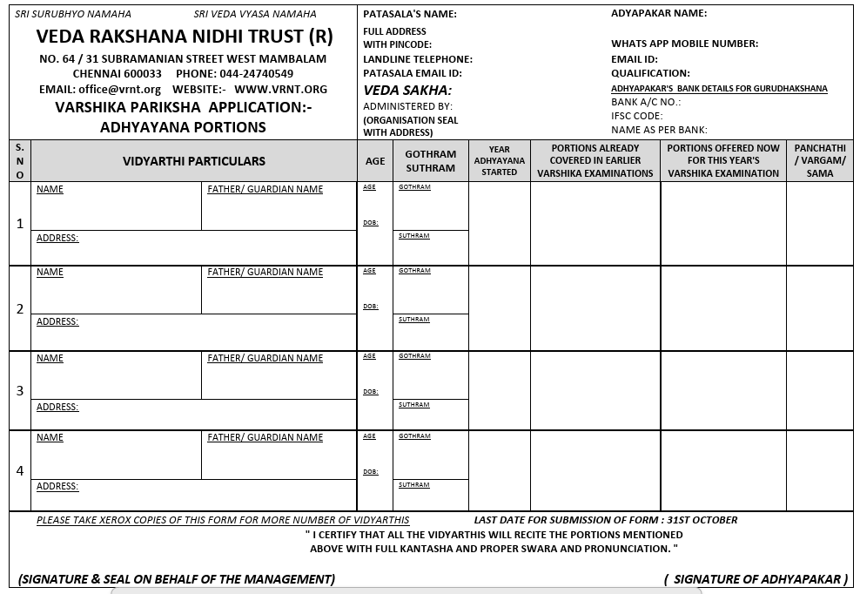

## Poorthy Application

## List of Gothrams

Most likely we will defer this feature.  
Will look into this later

## List of Soothrams

## Sanskrit Exam pre-requsite

Vidyaarthees have to clear Various levels of Sanskrit exams conducted by Chittoor Sabha

|  |  |  |
| --- | --- | --- |
| **Rig** | **Moolam** | Parichaya |
| **Kramam** | Abighignya |
| **Ghanam** | Vichakshana |
| **Yajur** | **Kramam** | Parichaya, Abighignya |
| **Ghanam** | Vichakshana |
| **Sama** | **Poorva Bhagam** | Parichaya, Abighignya |
| **Uththara Bhagam** | Vichakshana |
| **Atharva** | **Moolam** | ???? |

# Appendix – Sample forms currently being used

## Varshikam Forms

### Varshikam application Form

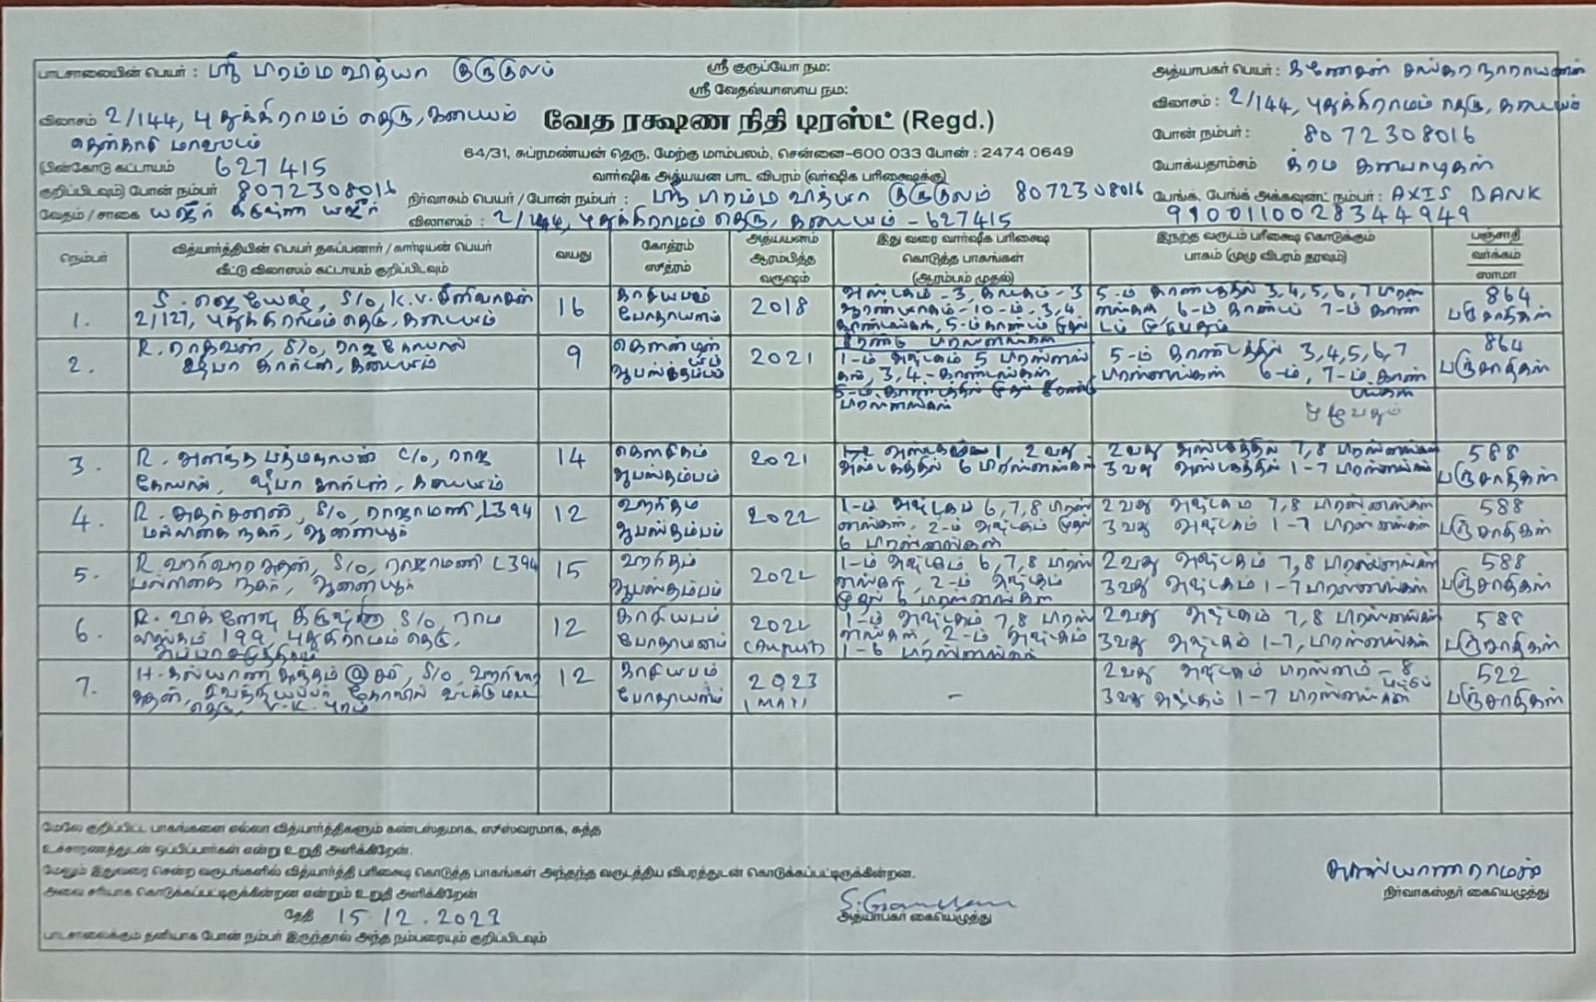

### Varshikam Pareekasha Result Form

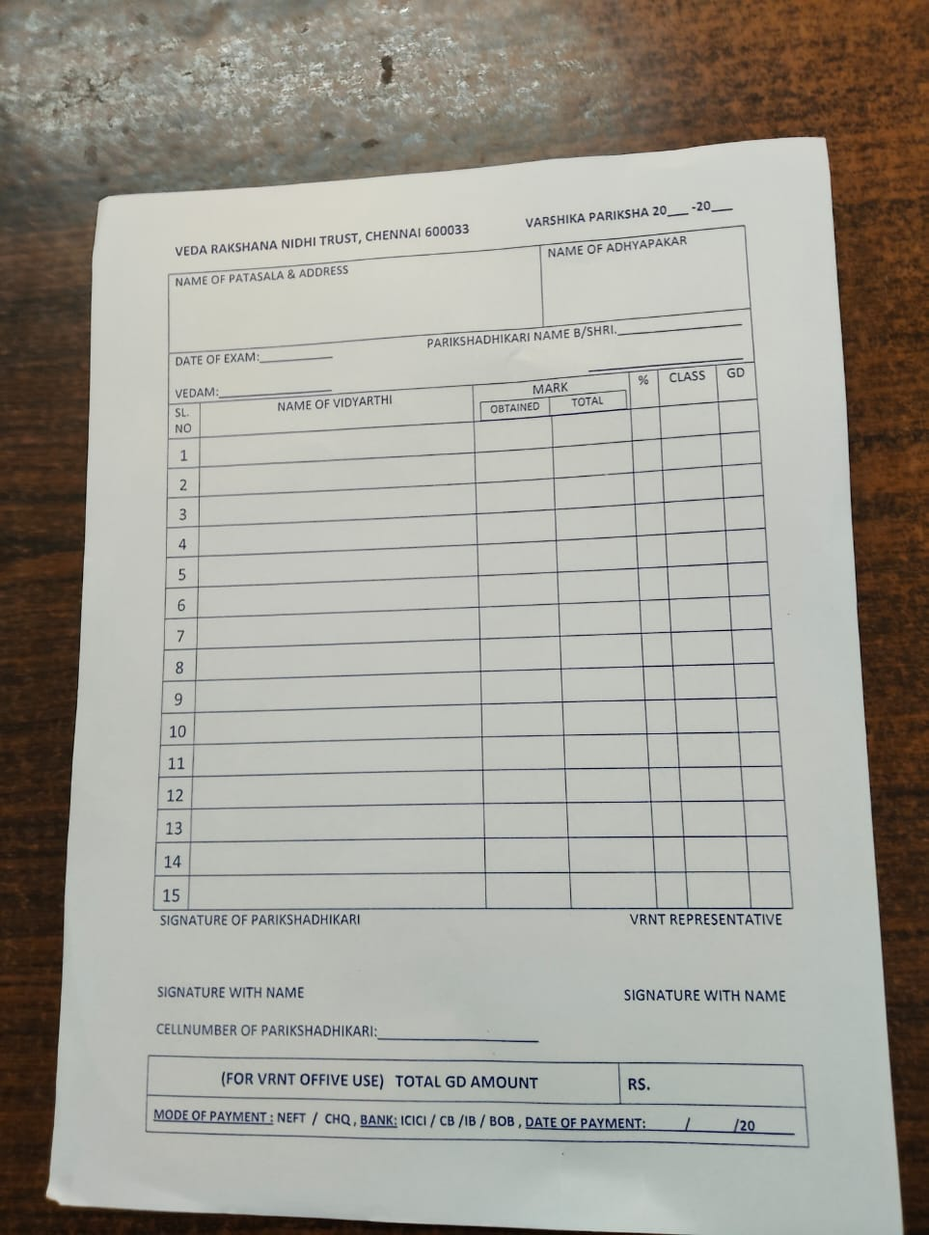

### Varshika Pareeksha Result Form -2

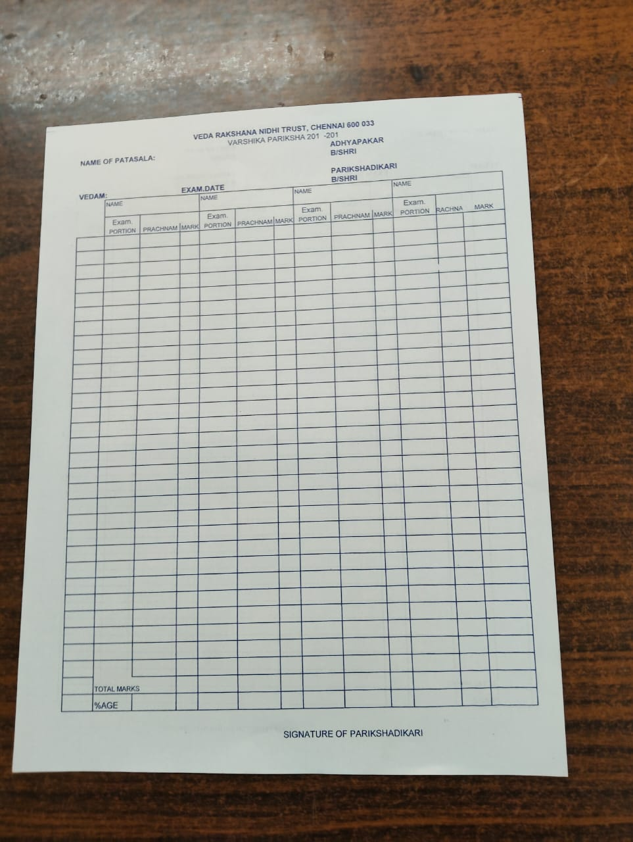

## Poorthy Exam forms

### Poorthy Exam Application Form

#### Page 1

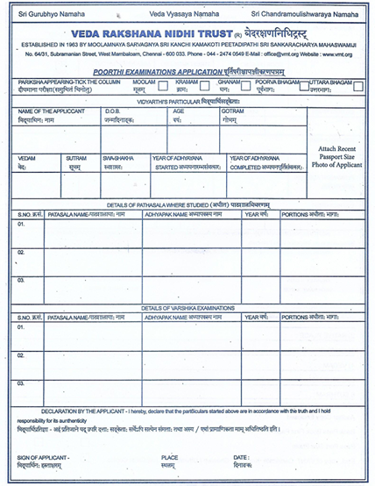

#### Page 2

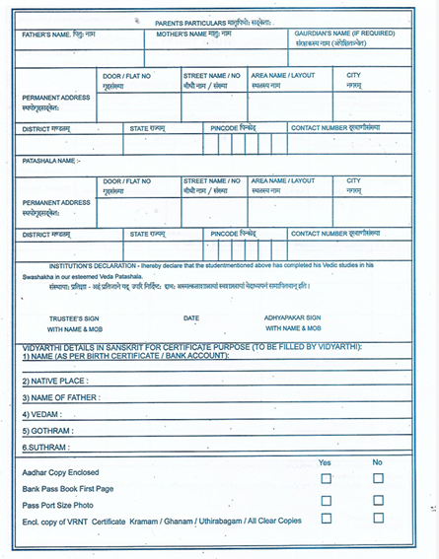

### Porrthy exam assessment form

#### Shukla Yajur vedam – Mandhyandhina shaka

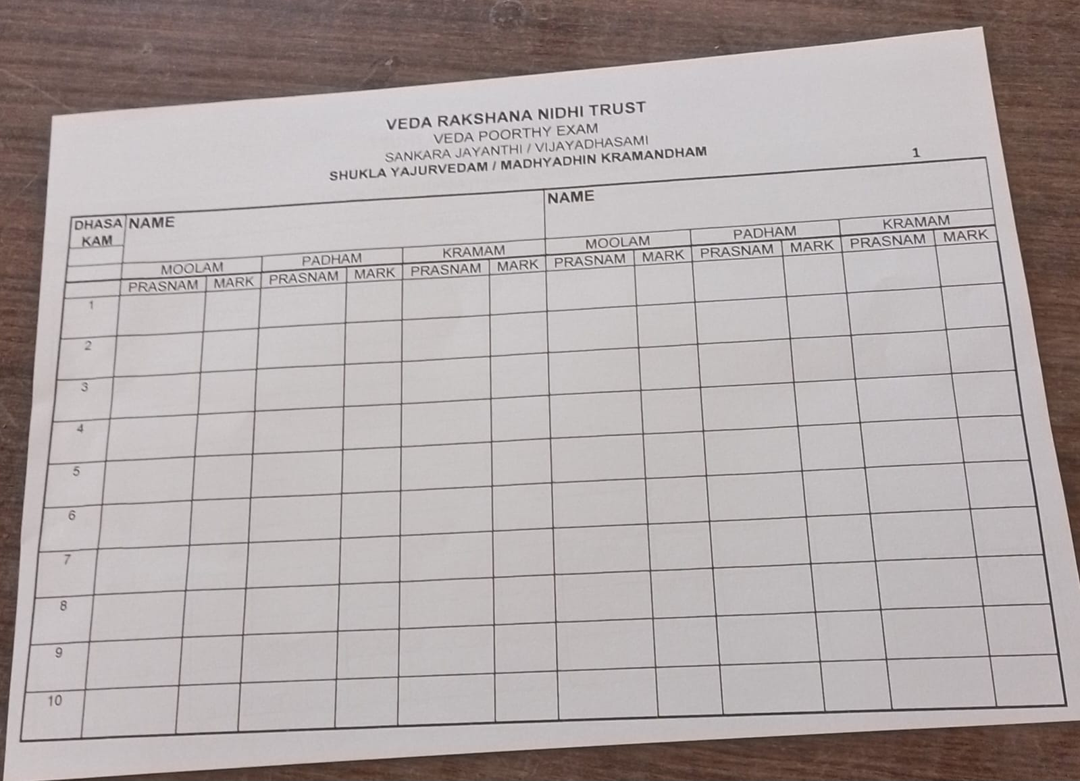

### Poorthy Pareeksha Certificate Form (Sanskrit)

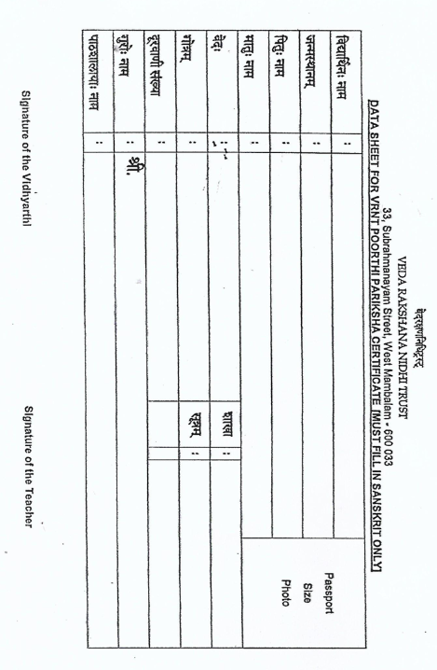

# UI design

# Future

* Shandangam to be addressed
  + Same for all veda / shaka
  + Eligibility criteria – Kramam
* Sanskrit language support
* Access to external users – like Vidyarthi-s and Patashala

# Notes from the call

* How to assign a unique id to the individual
* Can we use Aadhar OR not
* Guru – Sishya Parampara
* Vidyaarthees should able to enter Varshikam & Poorthy forms on their own
  + Eligibility will be shown then there
* Individuals (Neither HNY nor paatashala)
  + Need reference
  + Need to check swashaka
* Sanskrit exam
  + Pre-requisite to be checked
* Paatashala should notify VRNT about addition & deletion of vidyaaarthis
* Donor Management
* Need to Support Sanskrit Fonts in some screen
  + Especially Poorthy exam Certificate information

## Points for Inters

* Improve the UI
* Reak estate management should be better
* Make it more professional
* Validation for each field
* Shaka wise varshikam details
* All buttons should give a response – “not yet supported – Development in progress”
* More screens to be added
* Need a DB that UI can create & Use
* Algo for creating unique User -id
* Define Mandatory firled based on User type (Vidyathi, Gur, Father, Examiner, etc.)
* \